**DBMS LAB WEEK 4**

**NAME: Divyanshu Sharma**

**SRN: PES1UG20CS806**

**SECTION: “D”**

**SEMESTER: 5th**

**WEEK4 - SQL Constraints, Views, Truncate, delete and update operations**.

**Problem Statement 1: Create tables for the below mentioned Relational design and add check, default, not null and unique constraints**.

* PK and FK constraints for all applicable Relations
* For Fname, Lname in employee add not null constraints and relationship in dependent should be not null and by default add parent as the relationship value
* Add defult constraint for project name
* Dname and dnumber should be unique
* Add check constraints to BDATE in employee and dependent table (born before 1985)

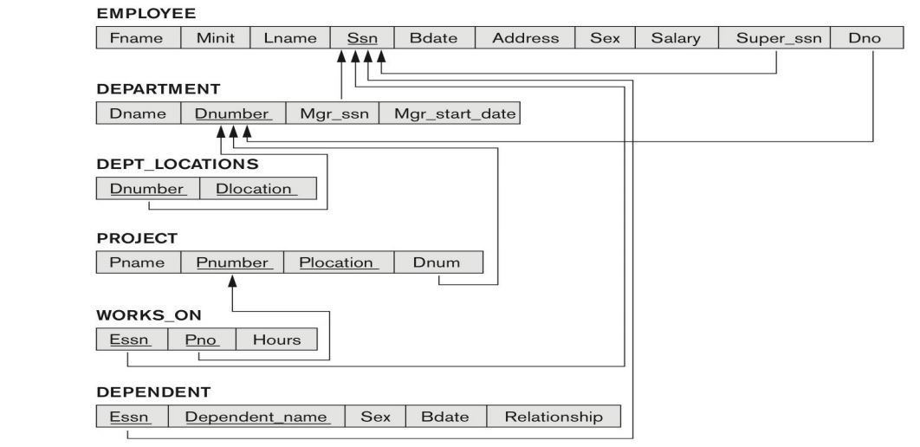

**SOLUTION:**

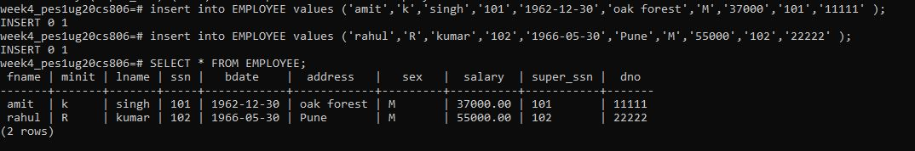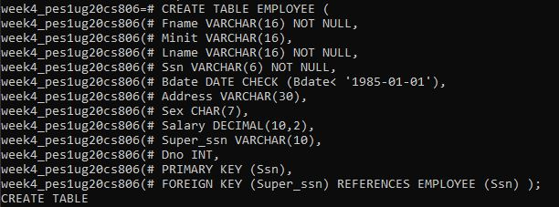**Employee Table:**

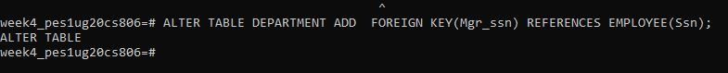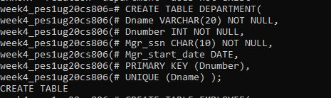**Department Table:**

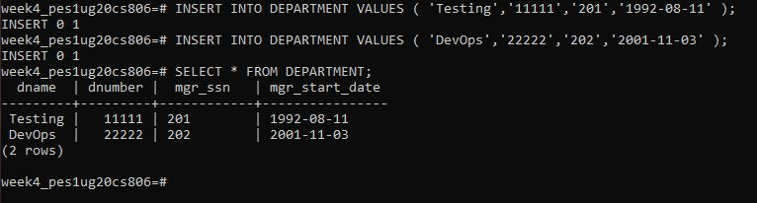

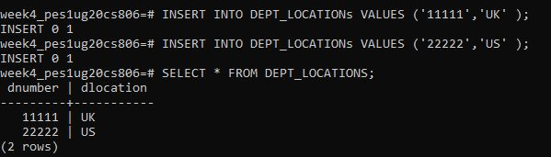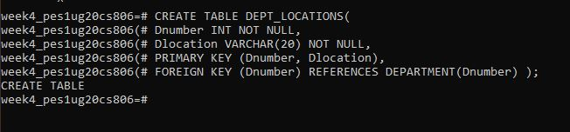**Dept_Locations:**

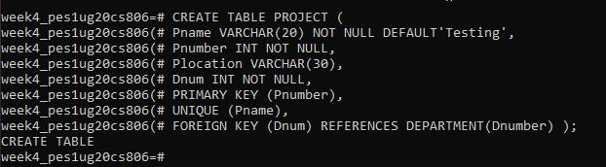**Project:**

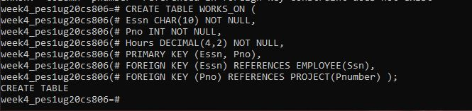**Works_On:**

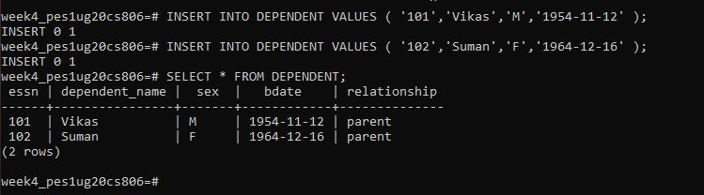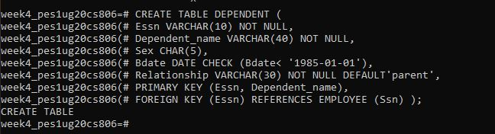**Dependent:**

**2. Perform the following operations on the table**

1. 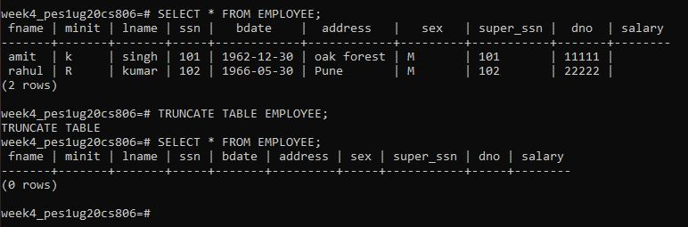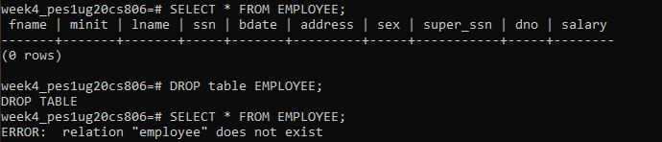**Drop and truncate**
2. 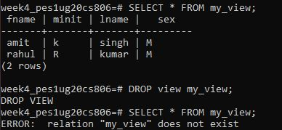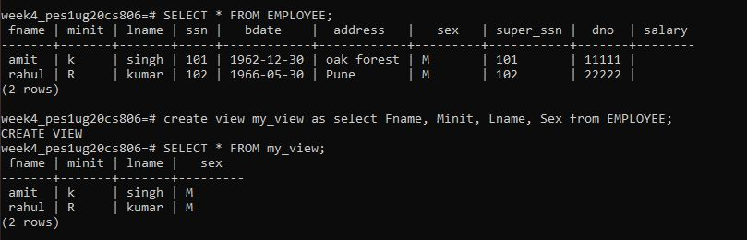**Create views and Drop views**
3. **Create user and grant and revoke privileges on the table**

* 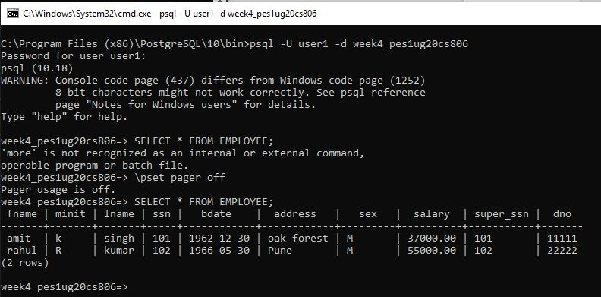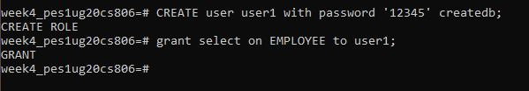**Grant select for emp table for user 1**
* 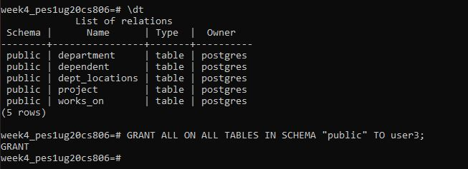**Grant all privileges on all the table for user 3**

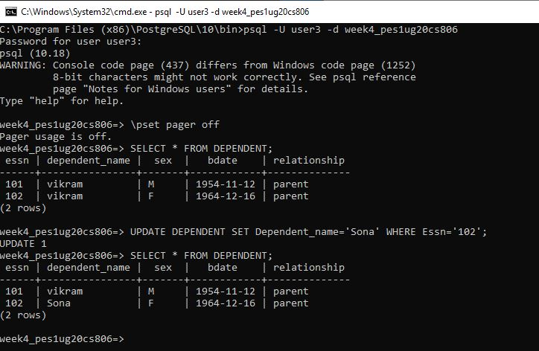

* 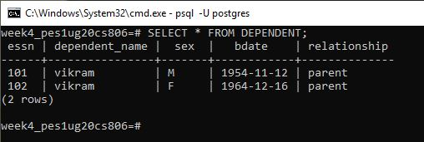**Grant alter, delete, update on dependent and project table for user4**

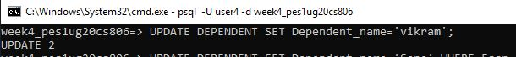

1. 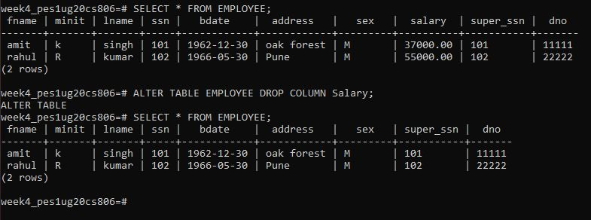**Using alter table commands add column, delete column**

